Michal Bochenek  
EC1401916

Binary Search Tree   
 Assessment outcome - report

Introduction:   
The binary search tree was created with java programing language, it does contain 5 methods such as:   
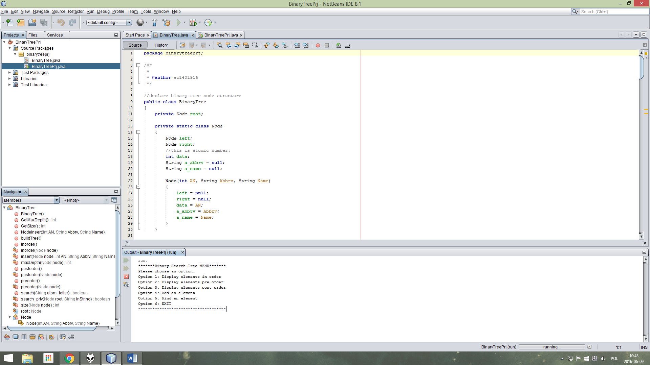  
  
  
Testing using previously made tree nodes:  
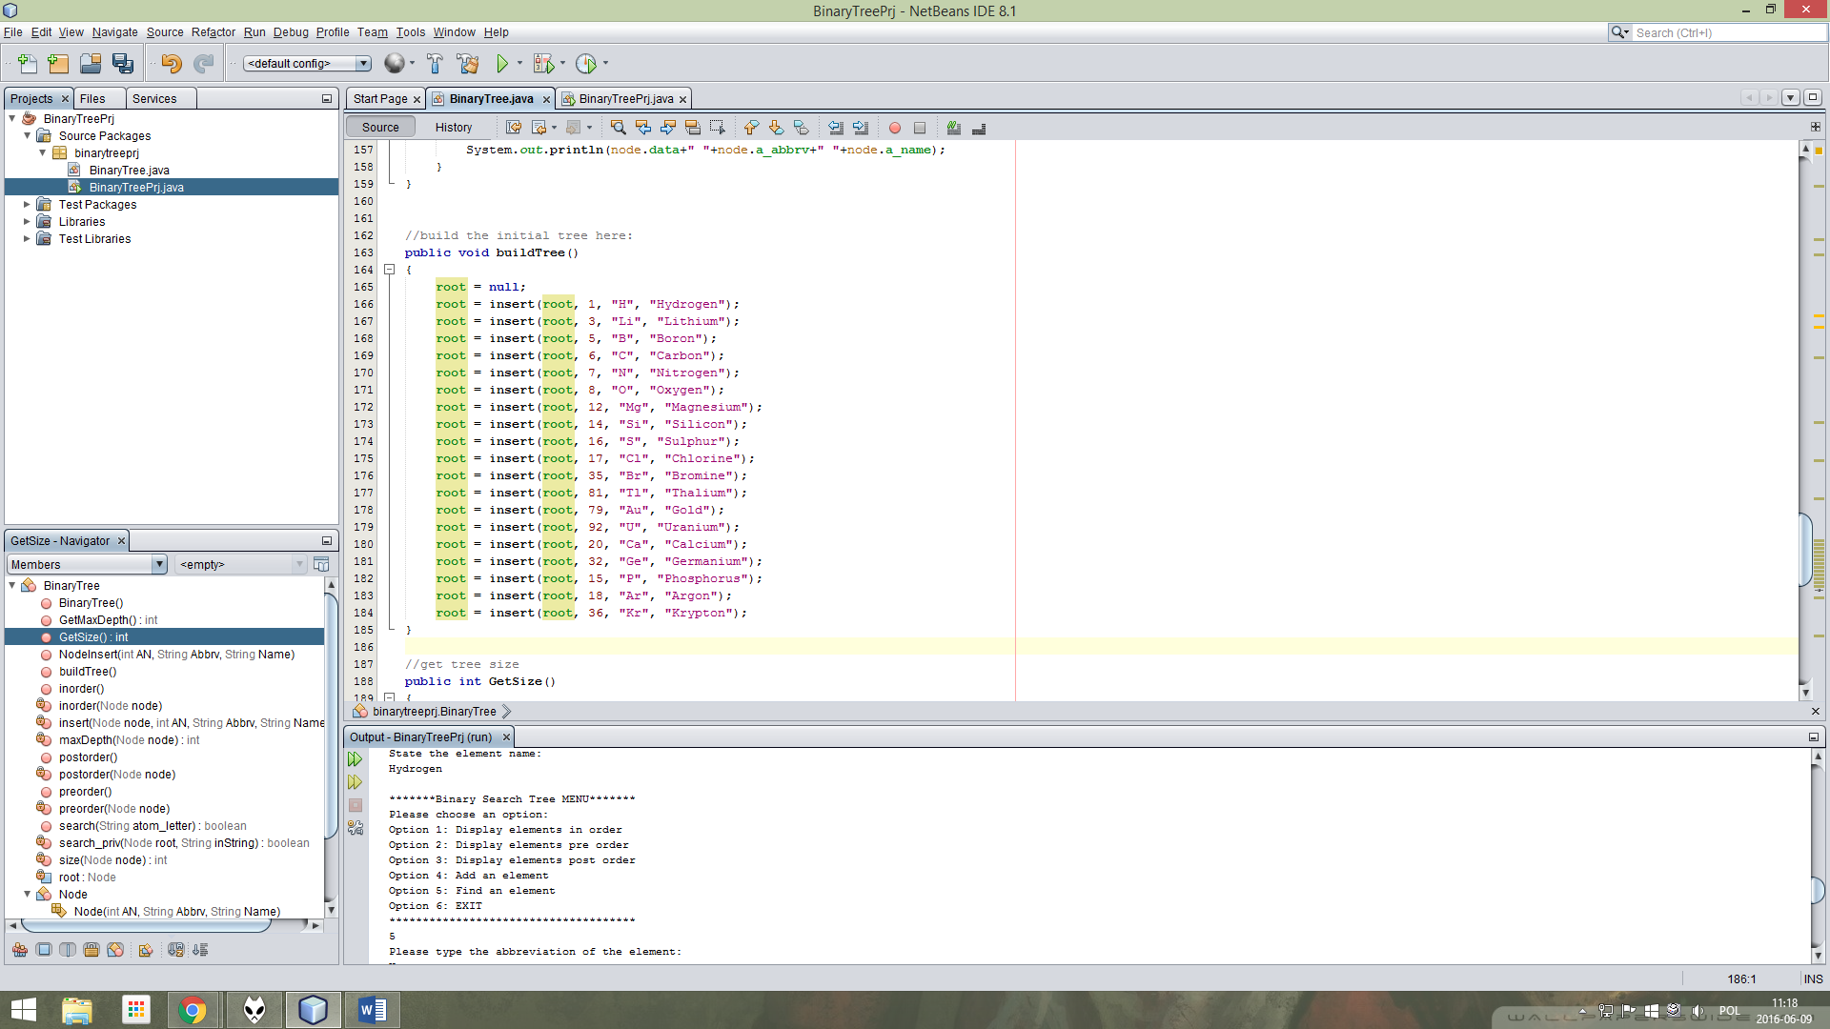

|  |  |  |  |
| --- | --- | --- | --- |
| Test nr. | Input | Expected | Output |
| 1. | Menu option 1: display elements in order | Tree is displayed: |  |
| 2. | Menu option 2: display elements pre order | Tree is displayed: |  |
| 3. | Menu option 3: display elements post order | Tree is displayed: |  |
| 4. | Menu option 4: add an element | Element is added. | **Testing how does the tree look now:** |
| 5. | Menu option 5: find an element (previously added Hydrogen – H – AN: 1) | Element information is displayed. |  |

Testing methods with an empty tree:  
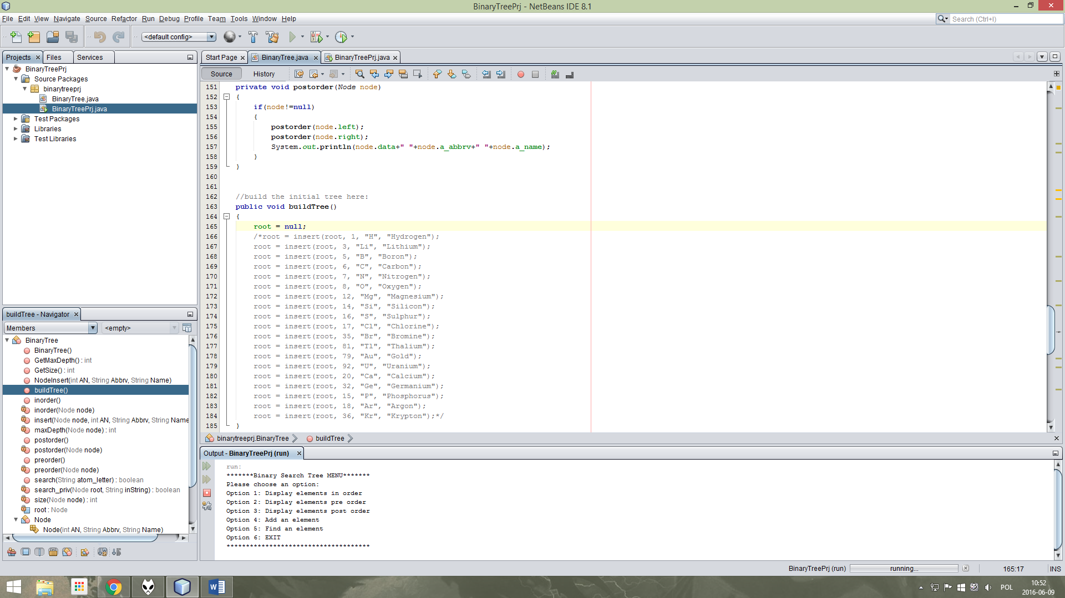

|  |  |  |  |
| --- | --- | --- | --- |
| Test nr. | Input | Expected | Output |
| 1. | Menu option 1: display elements in order | No tree is displayed. |  |
| 2. | Menu option 2: display elements pre order | No tree is displayed. |  |
| 3. | Menu option 3: display elements post order | No tree is displayed. |  |
| 4. | Menu option 4: add an element | Element is added. Tree now has 1 element and height 1. | **Testing if tree exists now:** |
| 5. | Menu option 5: find an element (previously added Hydrogen – H – AN: 1) | Hydrogen information is displayed. |  |